Homework 6

Assigned: October 15, 2024 (Wednesday)
Due: October 22, 2024 (Wednesday)

Problem 1:

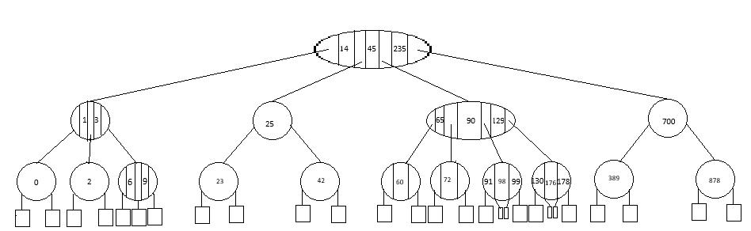
Convert the following 2-4 Tree into Red Black Tree. Depict the red nodes and edges with double circles and double line segments. [4-Marks]

Problem 2: [4 Marks]
- Insert 5, 12, 190 to 2-4-tree and the RB-tree obtained in Question 1.
- Delete 6, 0, 45 and 878 from 2-4-tree and RB-tree after insertions in problem 2a.
Problem 3: A binary tree with 4000 elements has a height of “h”. Find the minimum value of “h” for following trees. [2 Marks]
- Binary Search Tree
- AVL-Tree
- 2-4-Tree
- Red-Black Tree
Problem 4: Find the maximum and minimum height of the following trees with 8,5 and 12 elements. [2 Marks]
- Binary Search Tree
- AVL-Tree
- 2-4-Tree
- Red-Black Tree

Problem 1:new tree with more readability.
